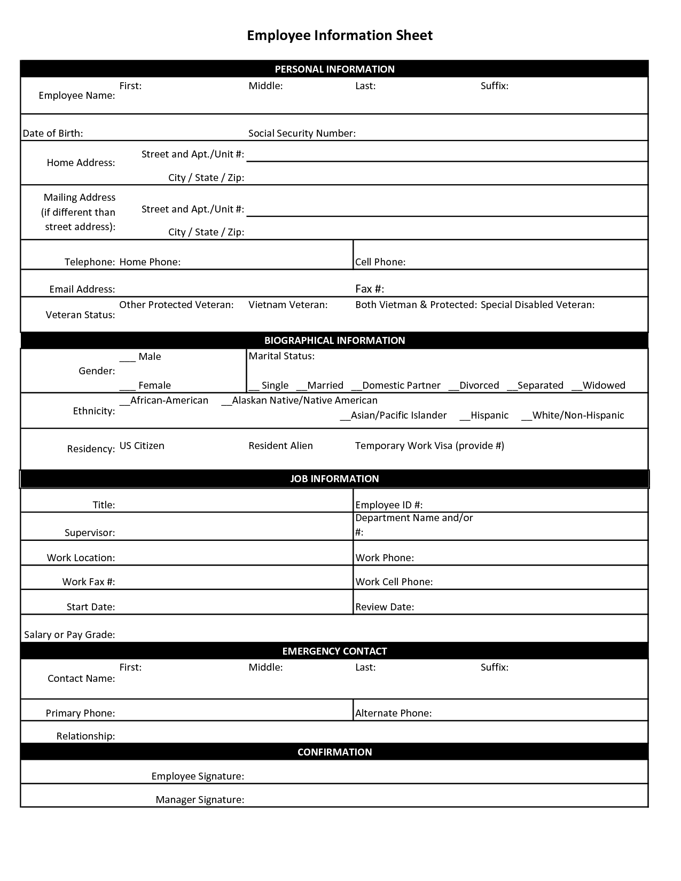
EMPLOYEE APPLICATION
START DATE:

STAFF MEDICAL REPORT
(To be completed by all staff and placed on file within 60 days of initial employment)

NAME______________________________________________________________________
Last First Middle

HOME ADDRESS____________________________________________________________

TELEPHONE NUMBER______________________________________________________

TO BE COMPLETED BY THE PHYSICIAN:

Some lifting of young children and some picking up and moving of furniture and equipment may be required. Since we are vitally involved with the wholesome emotional growth of the child, we require good mental and physical health of our employees.

Does this applicant have any physical condition which would limit their work with children? If yes, please describe: ___________________________________________________________________ ________________________________________________________________________________
________________________________________________________________________________

Is this applicant currently under treatment which would preclude their work with children? If yes, please describe: ___________________________________________________________________________ ___________________________________________________________________________________
___________________________________________________________________________________

Is this applicant currently under treatment for any specific condition? If yes, please describe:
___________________________________________________________________________________
___________________________________________________________________________________
___________________________________________________________________________________

Is this applicant currently taking any medication that would affect his/her work with children? If yes, please describe: ______________________________________________________________________ ___________________________________________________________________________________
___________________________________________________________________________________

In your opinion, is this applicant emotionally and physically capable to care for children on a daily basis?
____________________________________________________________________________________
____________________________________________________________________________________
____________________________________________________________________________________

Date of Examination: ____________________ _____________________________
Signature of Physician

Address of Physician: ___________________________________________________________

Phone Number of Physician: _____________________________________________________

EDUCATION
Circle the highest grade completed: 1 2 3 4 5 6 7 8 9 10 11 12 GED
College 1 2 3 4
Education | School/Institution | Dates | Diploma/Degree/Certificate
High School
College
Graduate
Other

Additional Skills:

TUBERCULOSIS TESTING FORM
10A NCAC 09 .0701 (a) (Centers)

Record of Tuberculosis Test
Last name (print clearly) | First name | Middle | Date of birth

Type of test:
- Tuberculin
Date given
Date read
Results | MM reading: __________  Negative  Positive

- Interferon Gamma Release Assay
Date
Results

Comments:
Signature of Authorized Health Professional | Date | Location

The North Carolina Child Care Health and Safety Resource Center
NC DHHS DPH - Communicable Disease Branch and DCDEE
Updated December 2017
EMERGENCY INFORMATION ON STAFF
NAME: ___________________________________________________
ADDRESS: ___________________________________________________
NAME OF DOCTOR: __________________________________________
DOCTOR’S PHONE NUMBER: _____________________________________
HOSPITAL PREFERENCE: _____________________________________
HOSPITAL PHONE NUMBER: _____________________________________

LIST ANY CHRONIC MEDICAL CONDITIONS, INCLUDING MEDICATIONS TAKEN FOR THAT CONDITION, WHICH WOULD BE RELEVANT IN AN EMERGENCVY SITUATION:
_______________________________________________________________________________________________________________________________________________________________________________________

EMERGENCY CONTACT PERSONS:

NAME: ___________________________ RELATIONSHIP: _________
ADDRESS: ___________________________________________________
CELL/HOME PHONE: ______________ WORK PHONE: ______________

NAME: ___________________________ RELATIONSHIP: _________
ADDRESS: ___________________________________________________
CELL/HOME PHONE: ______________ WORK PHONE: ______________

STAFF HEALTH QUESTIONNAIRE
IMPORTANT – Current health information must be complete/updated annually

I, ______________________, certify that I am emotionally and physically fit to care for children.
________________________________ _______________________
Signature Date

This section for Child Care Center Director Only
Director’s Statement:
I understand that I may request another evaluation of the employee’s emotional and physical fitness to care for children when there is a reason to believe that there has been deterioration in the employee’s emotional or physical fitness to care for children, as stated in Child Care Rule 10A NCAC 09 .0701(b).

Signature: _________________________________ Date: _________________________

SHAKEN BABY SYNDROME
Belief Statement
We, White Oak Christian Child Care, believe that preventing, recognizing, responding to, and reporting shaken baby syndrome and abusive head trauma (SBS/AHT) is an important function of keeping children safe, protecting their healthy development, providing quality child care, and educating families.

Background
SBS/AHT is the name given to a form of physical child abuse that occurs when an infant or small child is violently shaken and/or there is trauma to the head. Shaking may last only a few seconds but can result in severe injury or even death¹. According to North Carolina Child Care Rule (child care centers, 10A NCAC 09 .0608, family child care homes, 10A NCAC 09 .1726), each child care facility licensed to care for children up to five years of age shall develop and adopt a policy to prevent SBS/AHT².
Procedure/Practice Recognizing:
- Children are observed for signs of abusive head trauma including irritability and/or high pitched crying, difficulty staying awake/lethargy or loss of consciousness, difficulty breathing, inability to lift the head, seizures, lack of appetite, vomiting, bruises, poor feeding/sucking, no smiling or vocalization, inability of the eyes to track and/or decreased muscle tone. Bruises may be found on the upper arms, rib cage, or head resulting from gripping or from hitting the head.
Responding to:
- If SBS/ABT is suspected, staff will³:
o Call 911 immediately upon suspecting SBS/AHT and inform the director.
O Call the parents/guardians.
O If the child has stopped breathing, trained staff will begin pediatric CPR⁴.
Reporting:
- Instances of suspected child maltreatment in child care are reported to Division of Child Development and
Early Education (DCDEE) by calling 1‐800‐859‐0829 or by emailing webmasterdcd@dhhs.nc.gov.
- Instances of suspected child maltreatment in the home are reported to the county Department of Social Services. Phone number: 252-728-3181

Prevention strategies to assist staff* in coping with a crying, fussing, or distraught child
Staff first determine if the child has any physical needs such as being hungry, tired, sick, or in need of a diaper change. If no physical need is identified, staff will attempt one or more of the following strategies⁵:
- Rock the child, hold the child close, or walk with the child.
- Stand up, hold the child close, and repeatedly bend knees.
- Sing or talk to the child in a soothing voice.
- Gently rub or stroke the child's back, chest, or tummy.
- Offer a pacifier or try to distract the child with a rattle or toy.
- Take the child for a ride in a stroller. • Turn on music or white noise.
- Other ____________________________________________________________________________________
- Other ____________________________________________________________________________________
In addition, the facility:
- Allows for staff who feel they may lose control to have a short, but relatively immediate break away from the children⁶.
- Provides support when parents/guardians are trying to calm a crying child and encourage parents to take a calming break if needed.
- Other ____________________________________________________________________________________

Prohibited behaviors
Behaviors that are prohibited include (but are not limited to):
- shaking or jerking a child
- tossing a child into the air or into a crib, chair, or car seat
- pushing a child into walls, doors, or furniture

Strategies to assist staff members understand how to care for infants
Staff reviews and discusses:
- The five goals and developmental indicators in the 2013 North Carolina Foundations for Early Learning and Development, ncchildcare.nc.gov/PDF_forms/NC_Foundations.pdf
- How to Care for Infants and Toddlers in Groups, the National Center for Infants, Toddlers and Families, www.zerotothree.org/resources/77‐how‐to‐care‐for‐infants‐and‐toddlers‐in‐groups
- Including Relationship‐Based Care Practices in Infant‐Toddler Care: Implications for Practice and Policy, the Network of Infant/Toddler Researchers, pages 7‐9,
www.acf.hhs.gov/sites/default/files/opre/nitr_inquire_may_2016_070616_b508compliant.pdf

Strategies to ensure staff members understand the brain development of children up to five years of age
All staff take training on SBS/AHT within first two weeks of employment. Training includes recognizing, responding to, and reporting child abuse, neglect, or maltreatment as well as the brain development of children up to five years of age. Staff review and discuss:
- Brain Development from Birth video, the National Center for Infants, Toddlers and Families, www.zerotothree.org/resources/156‐brain‐wonders‐nurturing‐healthy‐brain‐development‐from‐birth
- The Science of Early Childhood Development, Center on the Developing Child, developingchild.harvard.edu/resources/inbrief‐science‐of‐ecd/

Resources
List resources such as a staff person designated to provide support or a local county/community resource:
__________________________________________________________________________________________

__________________________________________________________________________________________

Parent web resources
- The American Academy of Pediatrics: www.healthychildren.org/English/safety‐prevention/athome/Pages/Abusive‐Head‐Trauma‐Shaken‐Baby‐Syndrome.aspx
- The National Center on Shaken Baby Syndrome: http://dontshake.org/family‐resources
- The Period of Purple Crying: http://purplecrying.info/
- Other ____________________________________

Facility web resources
- Caring for Our Children, Standard 3.4.4.3 Preventing and Identifying Shaken Baby Syndrome/Abusive Head Trauma, http://cfoc.nrckids.org/StandardView.cfm?StdNum=3.4.4.3&=+
- Preventing Shaken Baby Syndrome, the Centers for Disease Control and Prevention, http://centerforchildwelfare.fmhi.usf.edu/kb/trprev/Preventing_SBS_508‐a.pdf
- Early Development & Well‐Being, Zero to Three, www.zerotothree.org/early‐development
- Other ____________________________________

References
- The National Center on Shaken Baby Syndrome, www.dontshake.org
- NC DCDEE, ncchildcare.dhhs.state.nc.us/general/mb_ccrulespublic.asp
- Shaken baby syndrome, the Mayo Clinic, www.mayoclinic.org/diseases‐conditions/shaken‐babysyndrome/basics/symptoms/con‐20034461
- Pediatric First Aid/CPR/AED, American Red Cross, www.redcross.org/images/MEDIA_CustomProductCatalog/m4240175_Pediatric_ready_reference.pdf
- Calming Techniques for a Crying Baby, Children’s Hospital Colorado, www.childrenscolorado.org/conditions‐andadvice/calm‐a‐crying‐baby/calming‐techniques
- Caring for Our Children, Standard 1.7.0.5: Stress http://cfoc.nrckids.org/StandardView/1.7.0.5

Application
This policy applies to children up to five years of age and their families, operators, early educators, substitute providers, and uncompensated providers.
Communication

Staff*
- Within 30 days of adopting this policy, the child care facility shall review the policy with all staff who provide care for children up to five years of age.
- All current staff members and newly hired staff will be trained in SBS/AHT before providing care for children up to five years of age.
- Staff will sign an acknowledgement form that includes the individual's name, the date the center's policy was given and explained to the individual, the individual's signature, and the date the individual signed the acknowledgment
- The child care facility shall keep the SBS/AHT staff acknowledgement form in the staff member’s file.
Parents/Guardians
- Within 30 days of adopting this policy, the child care facility shall review the policy with parents/guardians of currently enrolled children up to five years of age.
- A copy of the policy will be given and explained to the parents/guardians of newly enrolled children up to five years of age on or before the first day the child receives care at the facility.
- Parents/guardians will sign an acknowledgement form that includes the child’s name, date the child first attended the facility, date the operator’s policy was given and explained to the parent, parent’s name, parent’s signature, and the date the parent signed the acknowledgement
- The child care facility shall keep the SBS/AHT parent acknowledgement form in the child’s file.

* For purposes of this policy, "staff" includes the operator and other administration staff who may be counted in ratio, additional caregivers, substitute providers, and uncompensated providers.

____________________ Effective Date

This policy was reviewed and approved by: Owner/Director (recommended) Date

DCDEE Child Care Consultant (recommended) Date Child Care Health Consultant (recommended) Date

Annual Review Dates

PARENT OR GUARDIAN ACKNOWLEDGEMENT FORM

I, the parent or guardian of
Child’s name

acknowledges that I have read and received a copy of the facility's Shaken Baby Syndrome/Abusive Head Trauma Policy.

Date policy given/explained to parent/guardian Date of child's enrollment

Print name of parent/guardian

Signature of parent/guardian Date

STAFF ACKNOWLEDGEMENT FORM:

I _______________________________ (name) acknowledge that I have read and received a copy of the facility's Shaken Baby Syndrome/Abusive Head Trauma Policy.

Date policy given/explained to staff person

Staff signature Date

